Midwest Regional Bone Dysplasia Clinics
Richard M. Pauli, M.D., Ph.D., Director
August 2007

PREVENTION OF KYPHOSIS
A SUMMARY FOR PARENTS AND CARETAKERS
OF CHILDREN WITH ACHONDROPLASIA

- What is a kyphosis?

Almost all babies with achondroplasia develop a kyphosis by the time they are 12 months old. A kyphosis is the “bump” you can see or feel along an infant’s spine.

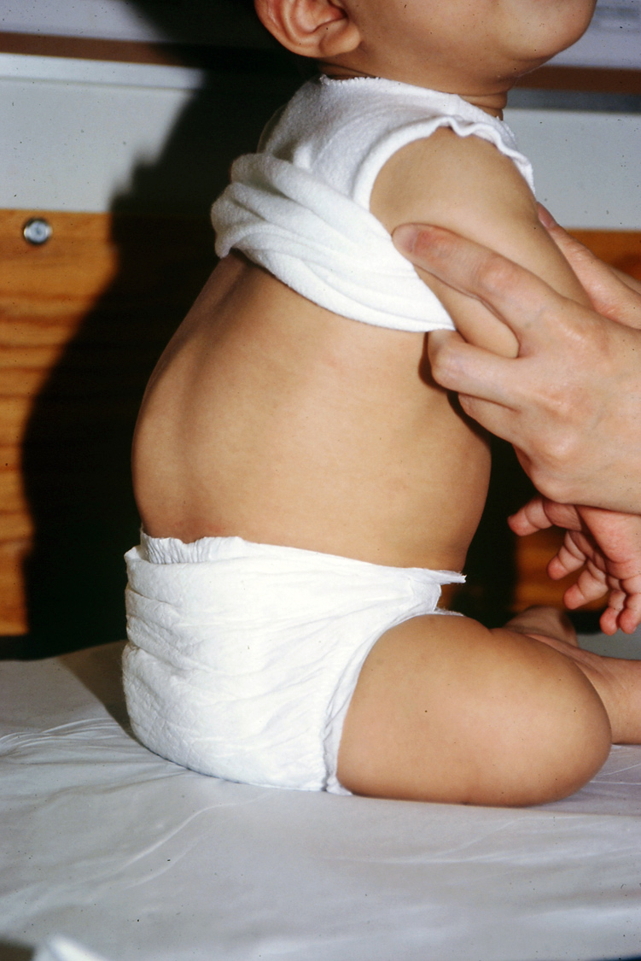
A typical kyphosis in a young infant
with achondroplasia.

Generally, the kyphosis improves as a baby gets older. However, in some babies the kyphosis becomes stiff and may not go away.

- What happens if a kyphosis becomes stiff?

A severe, stiff kyphosis is virtually never causes problems in childhood. However, in teenagers and adults a fixed kyphosis can cause neurologic problems such as partial paralysis of the legs, and/or bowel or bladder problems.

What causes the kyphosis to become stiff?

A kyphosis can worsen due to the interaction of a variety of factors. Those factors include: low muscle tone of the trunk; a large head; a fundamentally abnormal spine; and gravity.

Because a baby with achondroplasia has low muscle tone the trunk, he or she will naturally slump forward to a C-sitting posture. Gravitational force then acting on abnormal vertebrae over time can cause deformity of the vertebrae. If too much deformity occurs it can become irreversible.

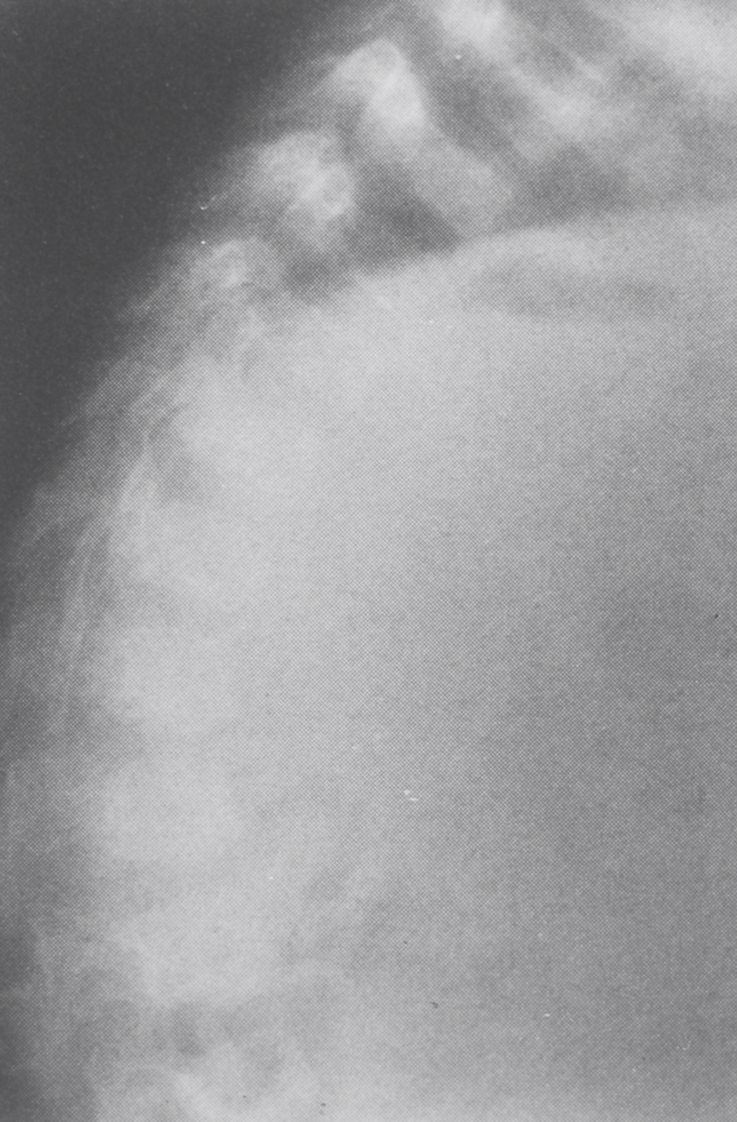
Xray of the spine of an infant with
achondroplasia. Although there is a
kyphosis, the backbones themselves
(arrows) are still of normal shape.

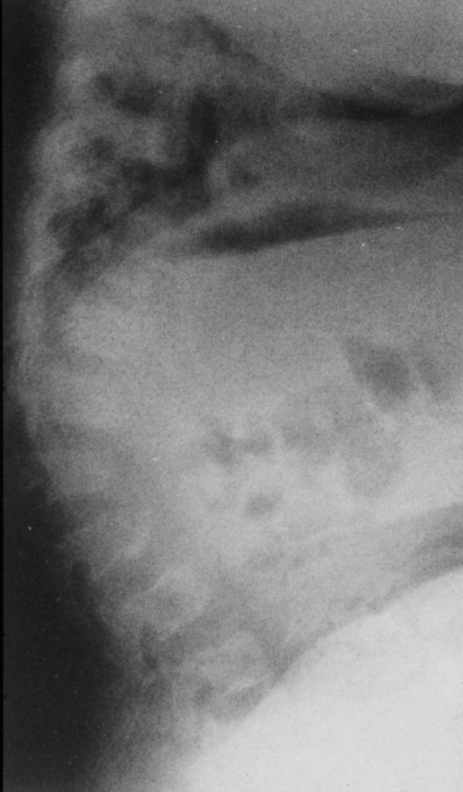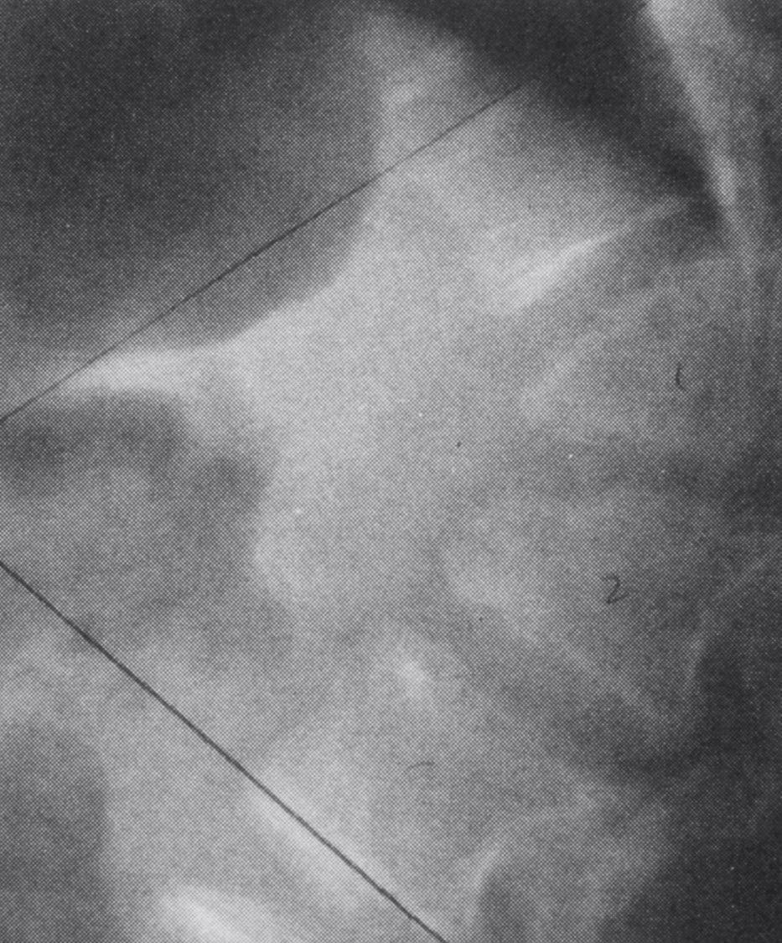
In this baby the kyphosis is more severe This xray shows how vertebrae can
and the vertebrae (backbones) have become severely wedged with time,
begun to lose bone in their front part – creating a sharp curve in the spine
becoming wedged. (arrows).
.

If a severe, fixed curve develops, then surgery before the occurrence of severe neurologic damage is recommended. Generally this is done in late childhood or in adolescence. This spinal fusion surgery is complicated and has risks for serious complications. So, strategies to reduce the chance of needing this kind of surgery are potentially of great benefit.

- How can I prevent my child’s kyphosis from becoming stiff?

There is substantial evidence that parents and caretakers can greatly reduce the risk for development of fixed, stiff kyphosis.

First, unsupported sitting should be avoided for at least the first 12-15 months of life. The poorer the muscle tone is in a baby’s trunk, the longer the baby should be kept out of a sitting position. This prohibition includes not allowing a baby to sit in a device that does not provide proper back support. Examples of such devices are umbrella strollers and most bouncy seats. Delaying independent sitting does not have any long term developmental consequences.

Infants with achondroplasia should be held with good back support using gentle pressure, applied by a hand, arm or one’s body, to the area where the kyphosis is present.

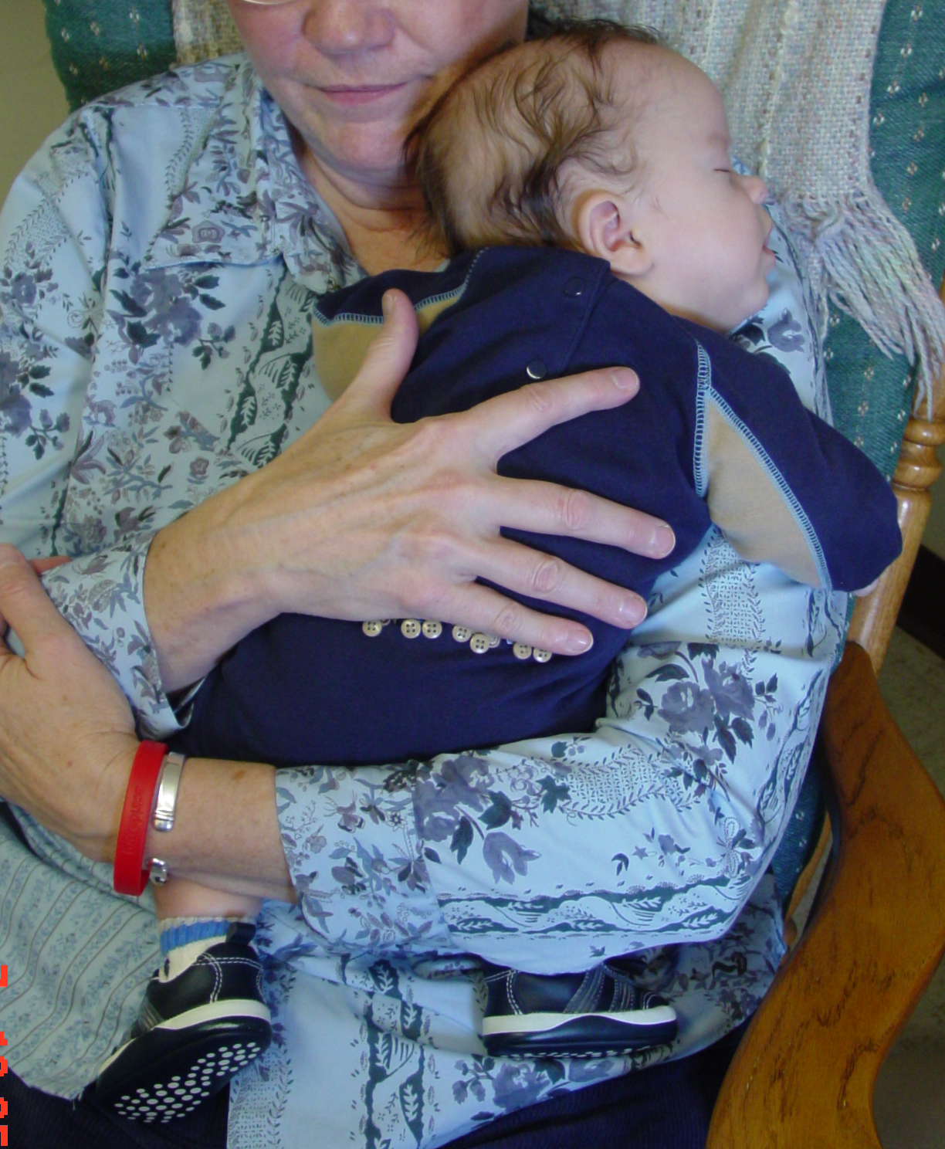
Appropriate holding technique, with counterpressure
applied with the palm of the hand.

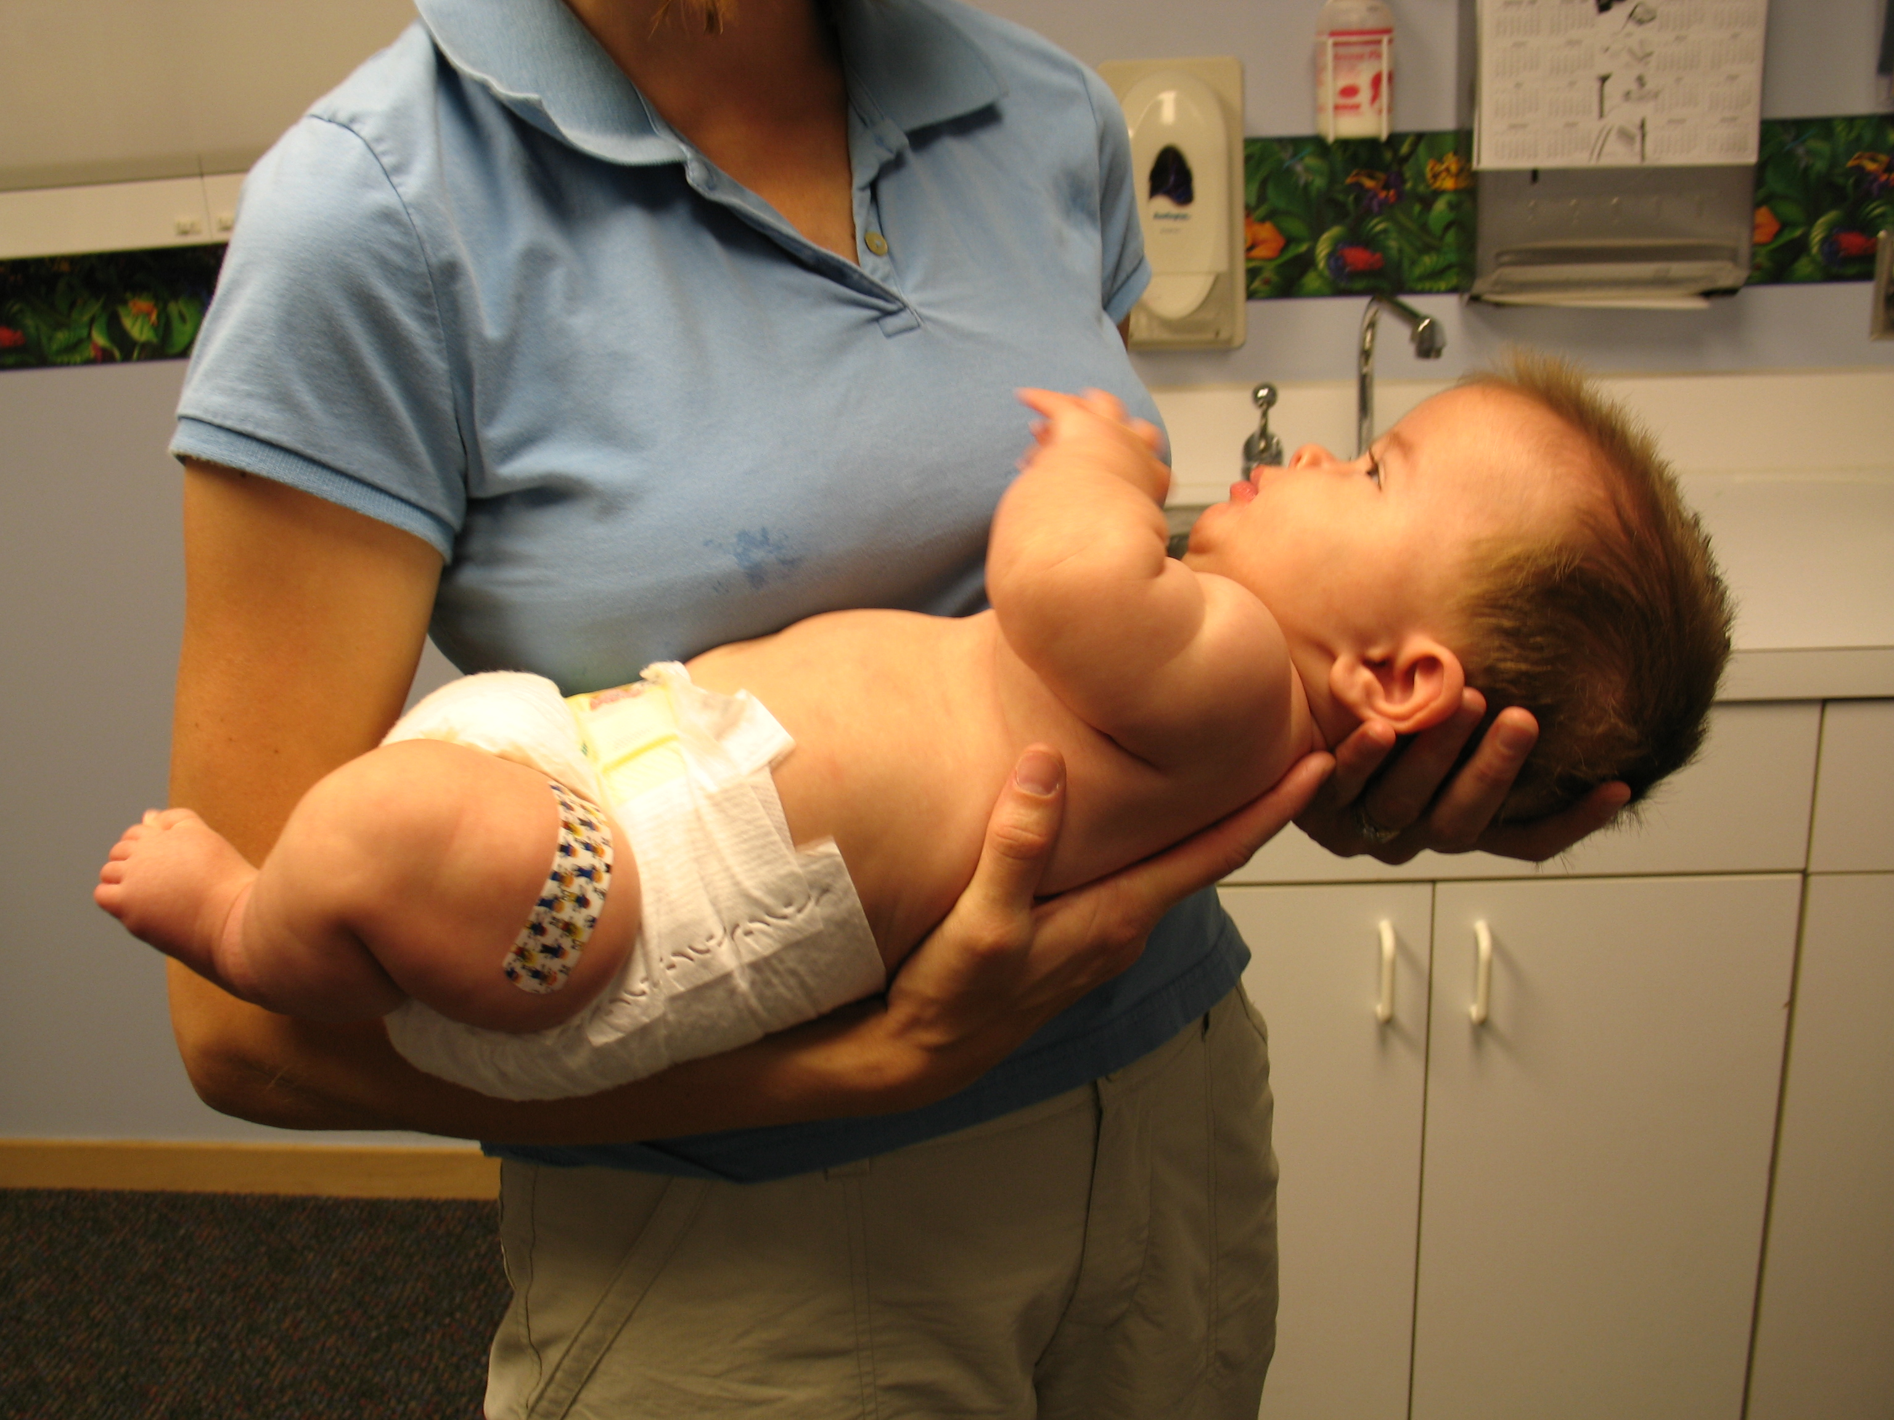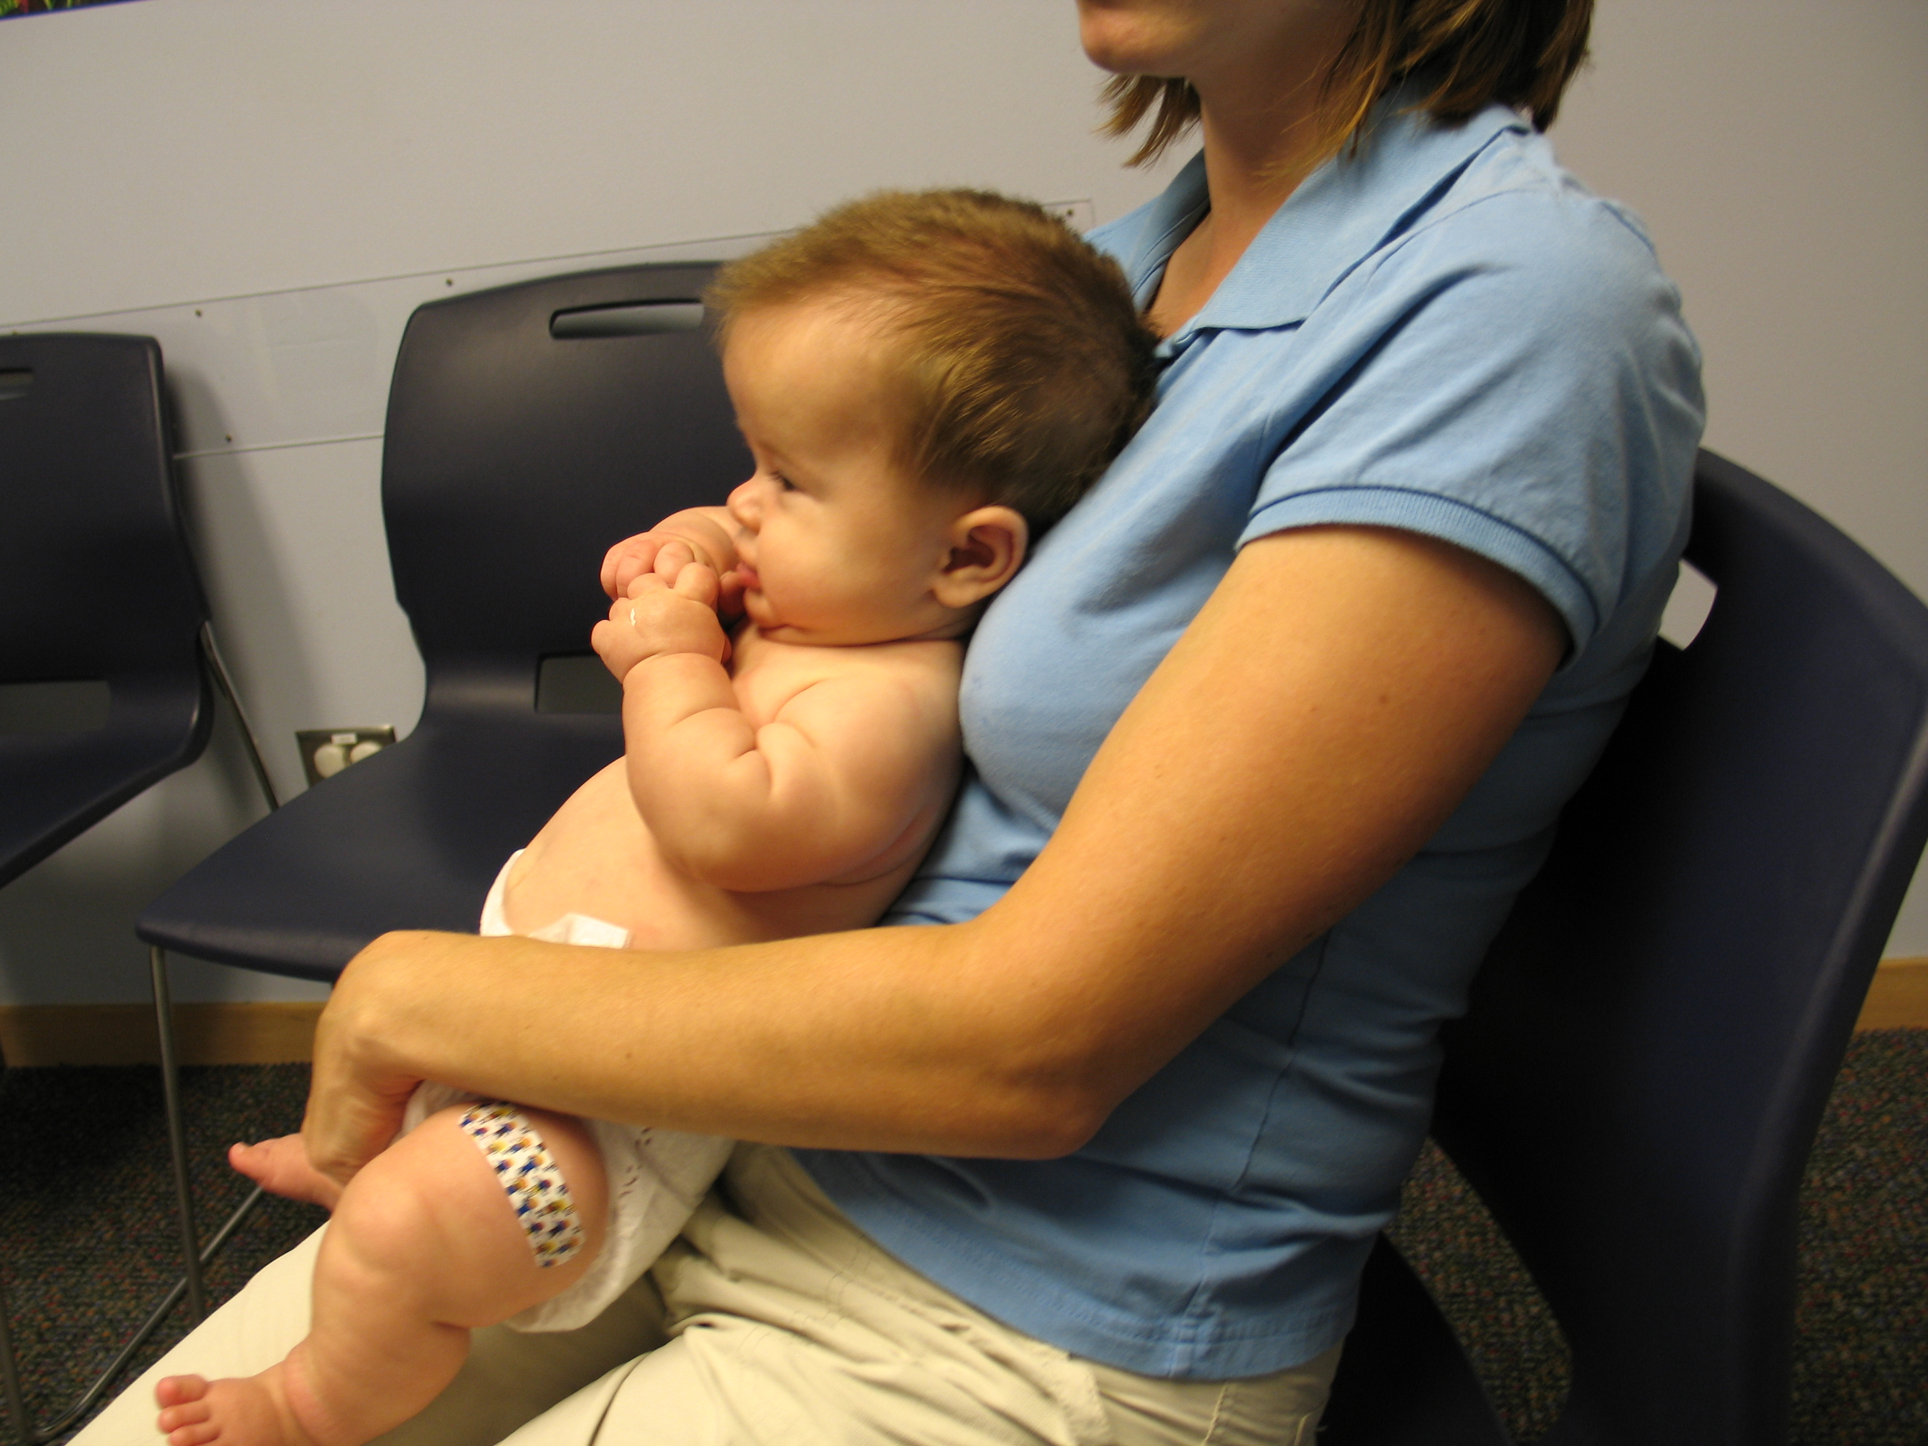
Another way to hold a baby that exerts appropriate Counterpressure being applied by the adult’s body so
pressure on the area of kyphosis. That this, too, decreases the likelihood that gravity,
acting on the spine in a disadvantageous position wil
cause the kyphosis to become fixed.

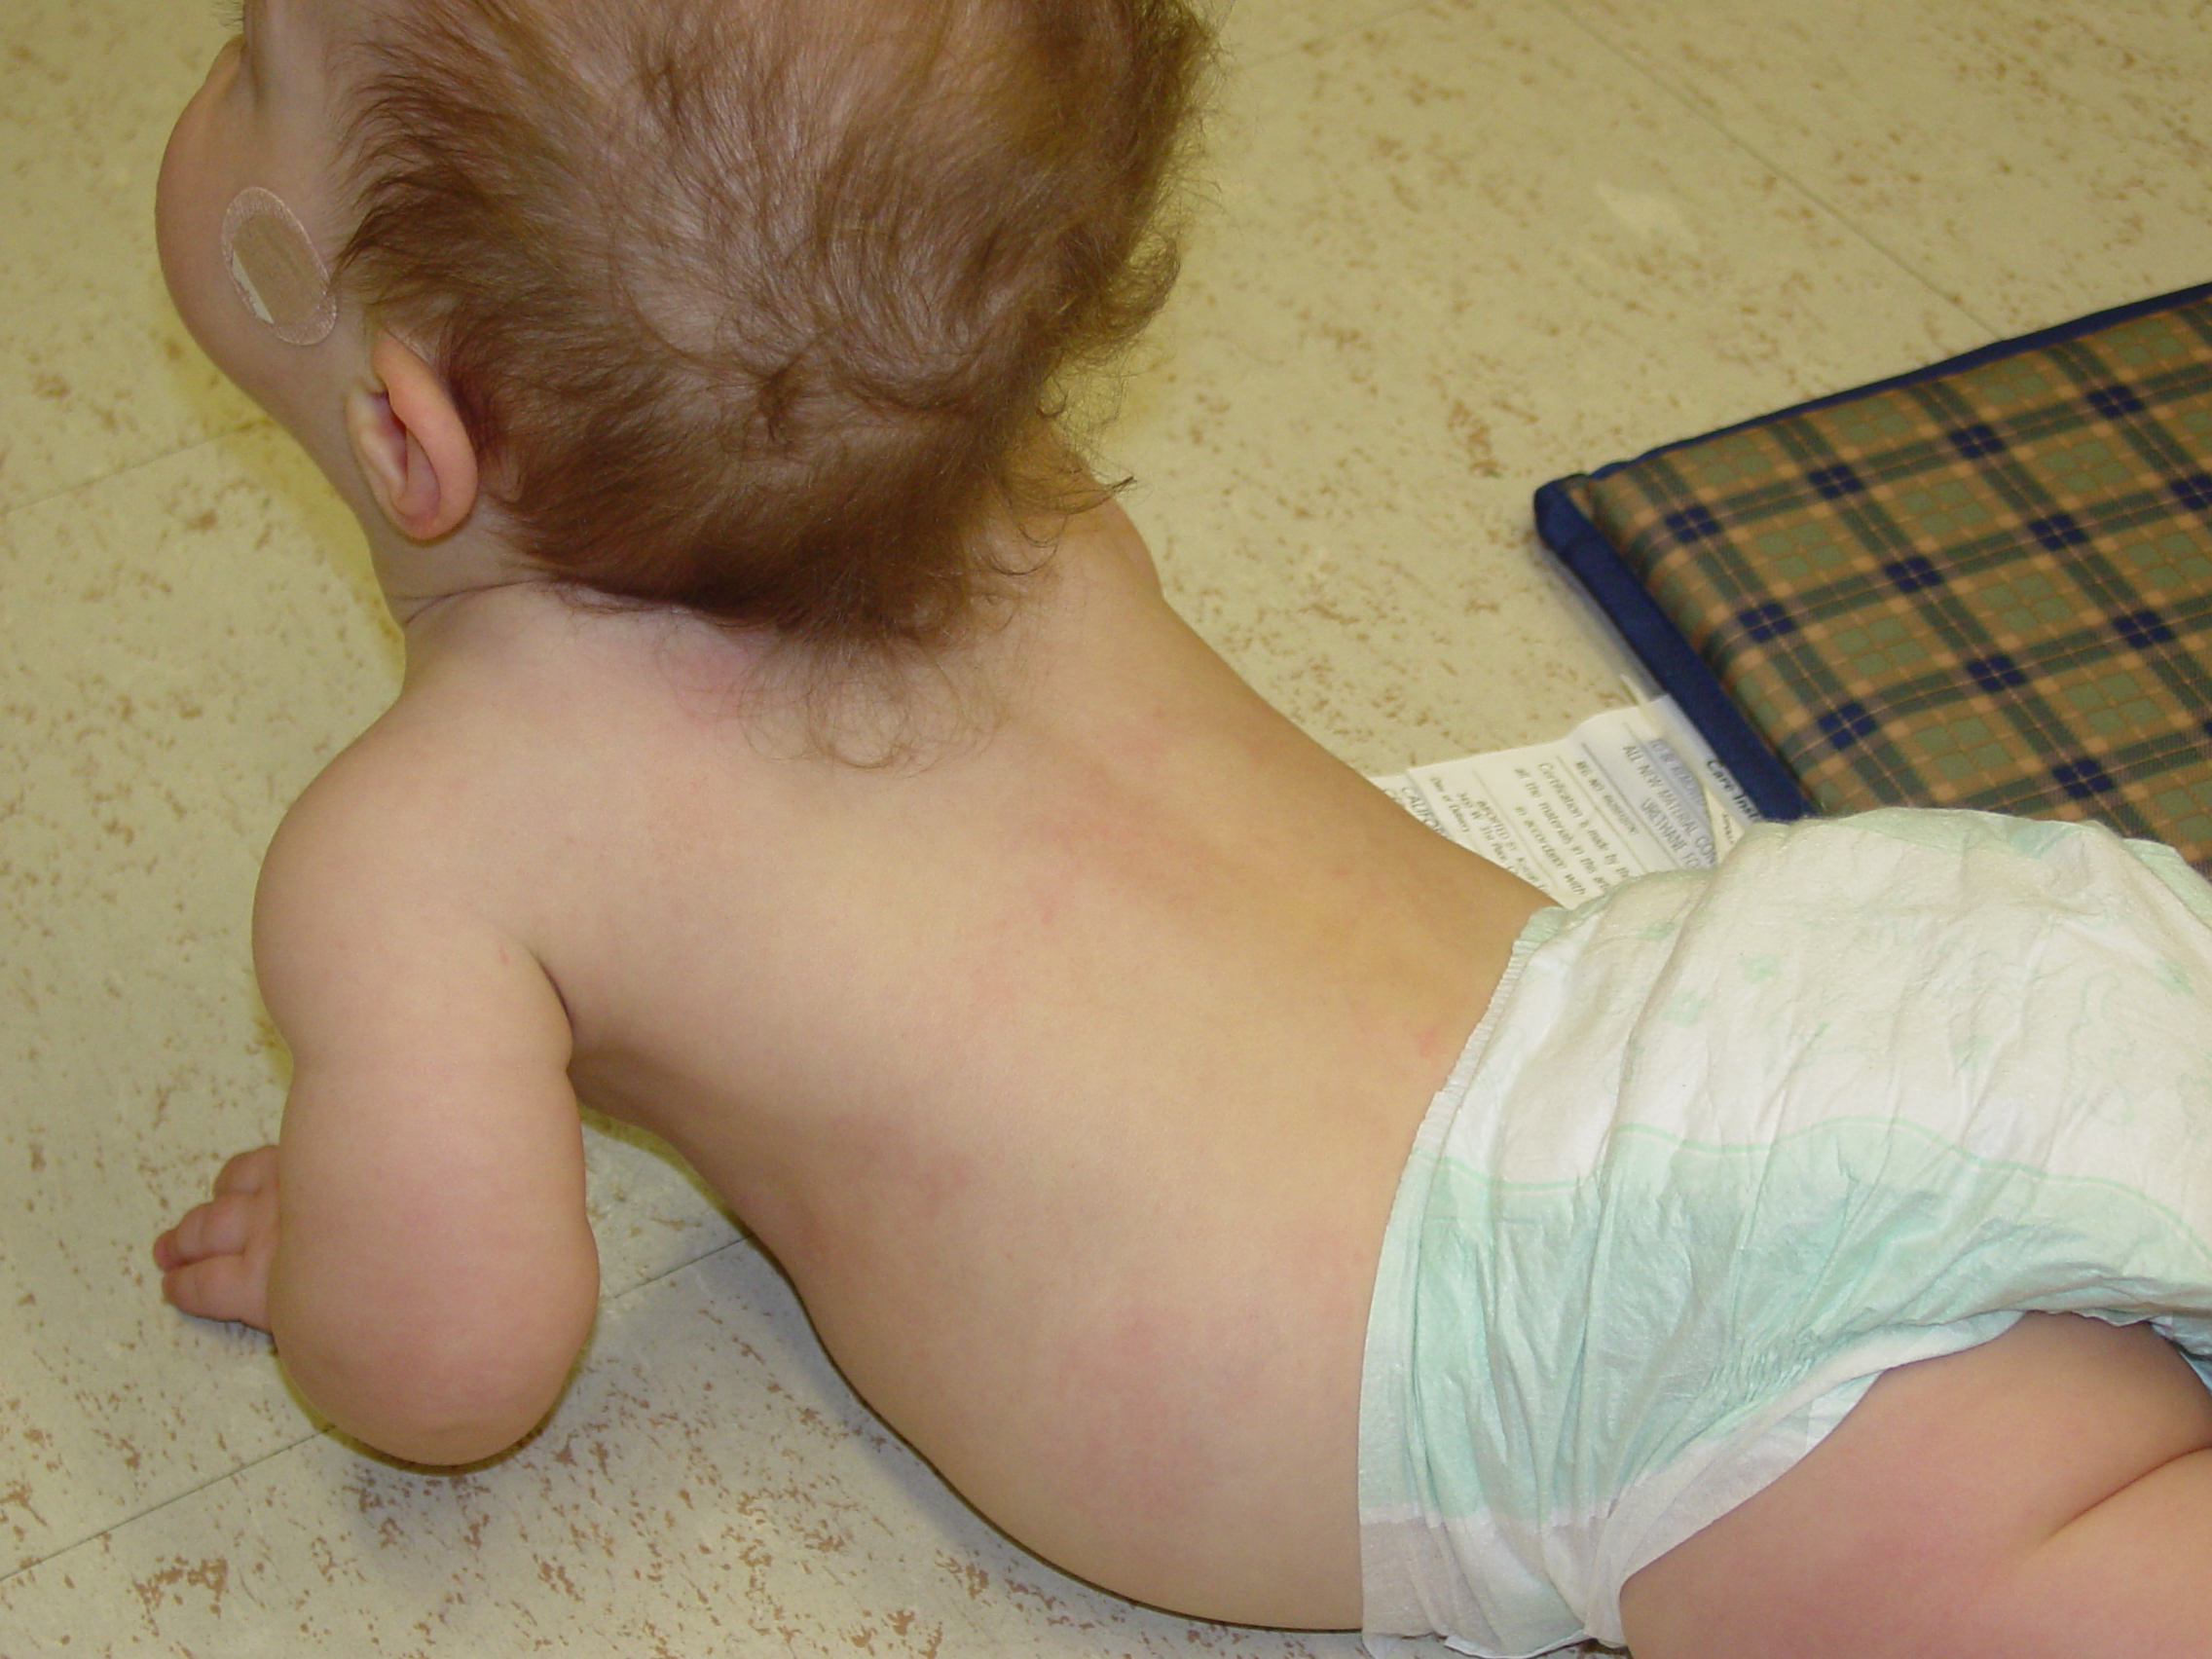
Infants should be encouraged to spend as much time as possible on their stomachs. In that position, the kyphosis is reversed, and, at the same time, the baby is strengthening the back and abdominal muscles that are needed to decrease C-sitting and so eventually eliminate the risk of a fixed kyphosis developing.

Arrow shows the reversal of the kyphosis when a baby
is placed prone (tummy down).

Car seats and infant carriers should be inspected to make sure they provide good back support. Some carriers have padding that ends right where the kyphosis begins. This provides no pressure against the kyphosis and allows the infant to C-sit. Foam padding can be inserted under the carrier’s fabric cover to extend the foam support further down the infant’s spine.

Following these simple steps has been shown to eliminate the risk of a fixed kyphosis in approximately 75% of all infants with achondroplasia.

- How do I know whether my child’s kyphosis is becoming too stiff?

Kyphosis can be measured by it’s appearance clinically and also by xrays. Clinically, tt is reassuring if the kyphosis greatly reduces when the child is on their stomach. Xrays may be needed if the physician thinks that accurate measurement of a kyphosis is needed.

When evaluated by xray, the curve may be found to be severe enough that further progression would place the child at risk for later neurologic problems. Then bracing is recommended. Use of a brace decreases the kyphosis and allows the abnormally shaped vertebrae to re-grow into a more normal shape.

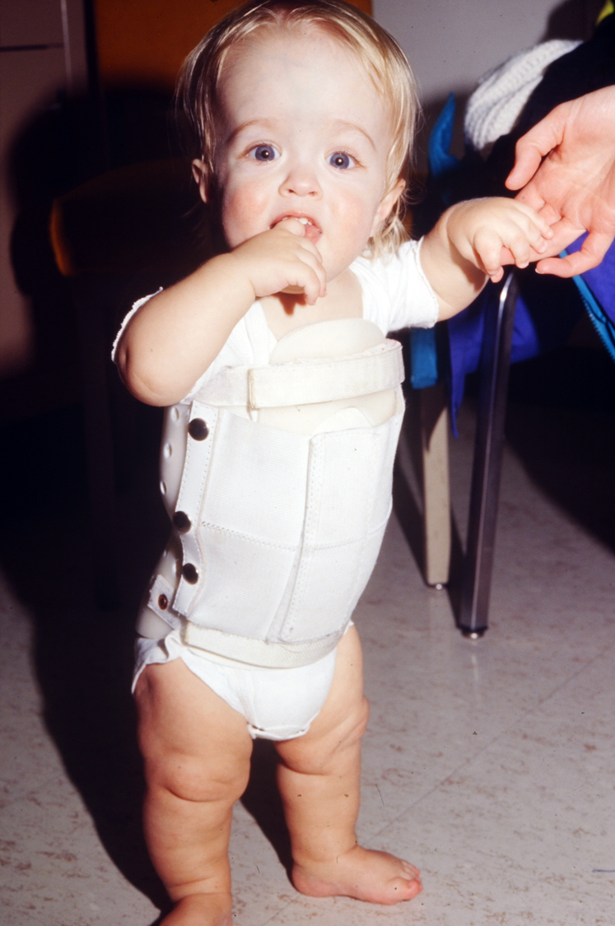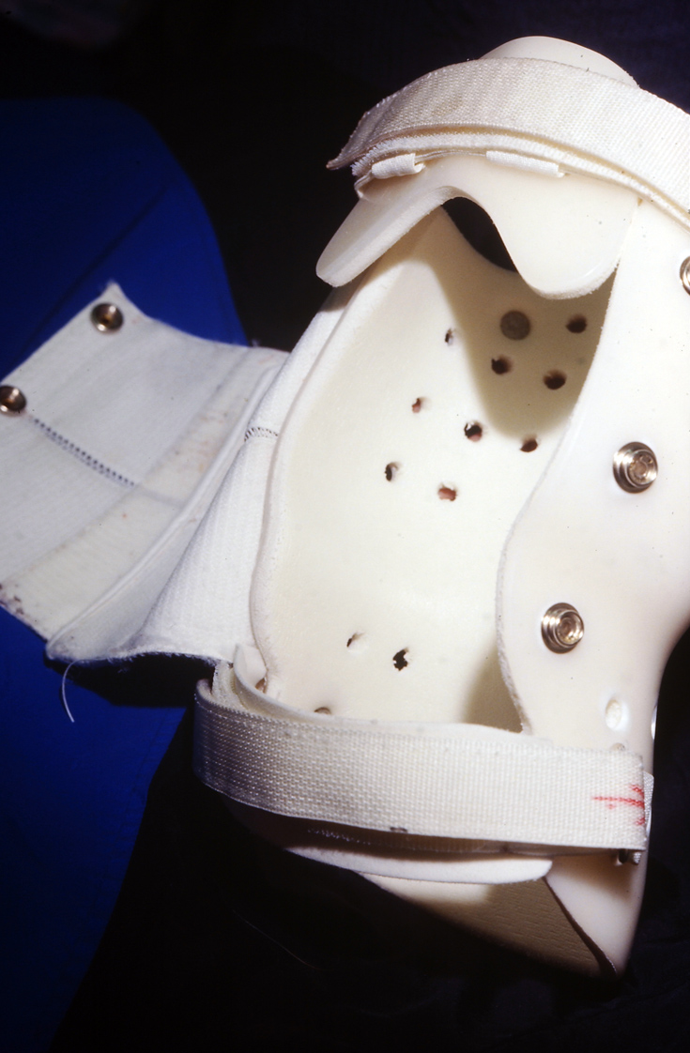

If needed, the brace should be worn as many hours a day as possible. Brace use at all times – day and night – except during bathing is optimal. Xrays are used to determine when the brace can be discontinued. In general, a kyphosis can be reversed with anywhere from 6 to 24 months of bracing.

- Who can I contact with additional questions?

Questions can be referred to:

Peggy Modaff, M.S. or Catherine Reiser, M.S.
Genetic Counselors
Clinical Genetics Center & Midwest Regional Bone Dysplasia Clinic
University of Wisconsin-Madison
modaff@waisman.wisc.edu
reiser@waisman.wisc.edu

Richard M. Pauli, M.D., Ph.D.
Professor, Pediatrics and Medical Genetics
Director, Midwest Regional Bone Dysplasia Clinic
University of Wisconsin-Madison
1500 Highland Avenue, #353
Madison, WI 53705

